Pictorial
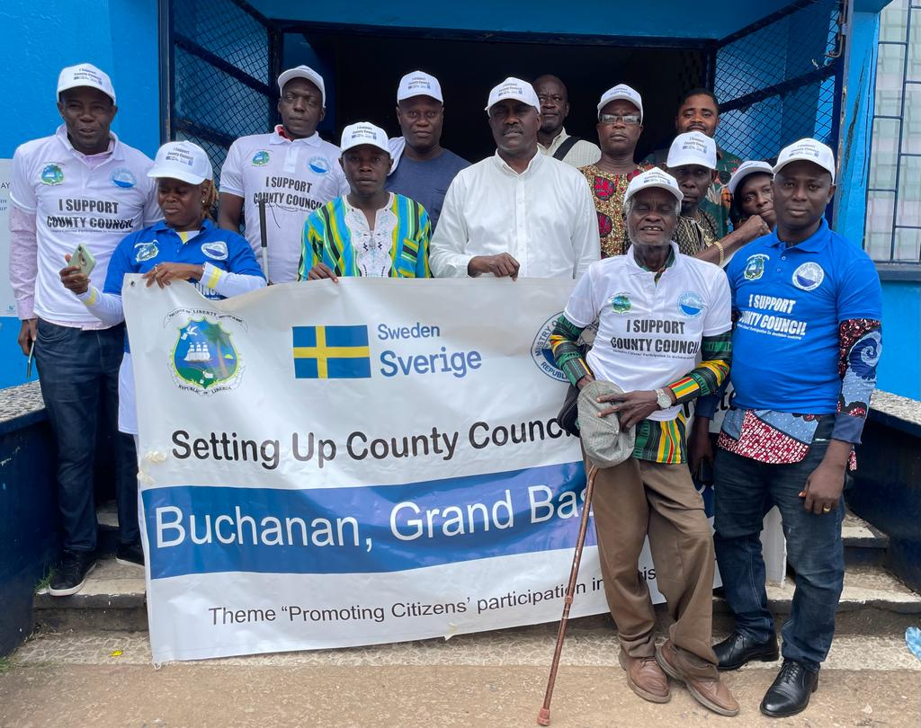
Fig. 1: Hon. Olayee Collins, Deputy Minister for Research and Development Planning pose for a photo with members of the recently established Grand Bassa County Council.

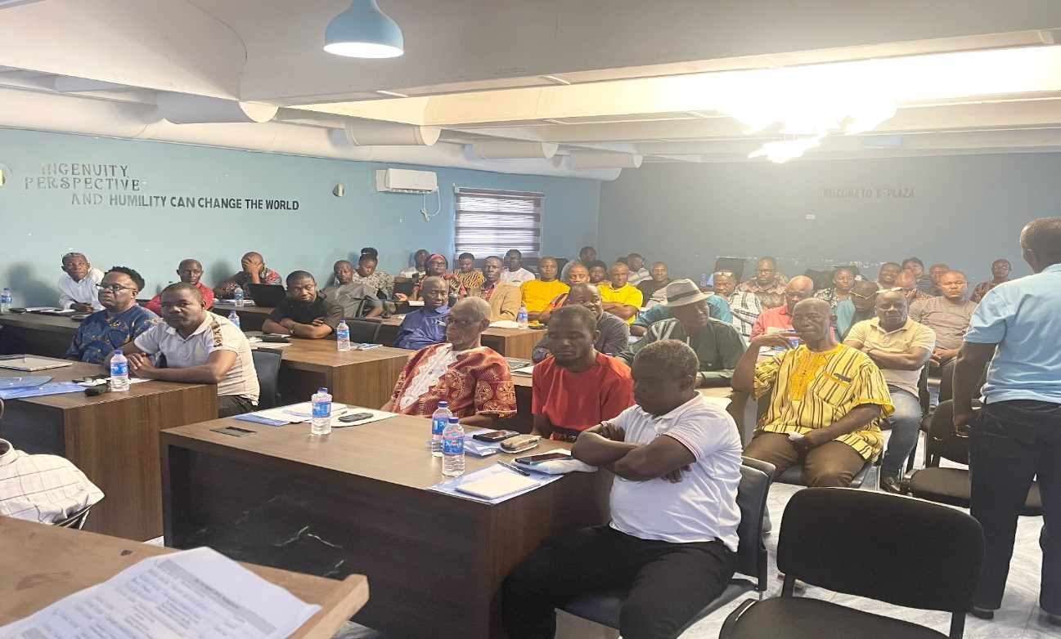
Fig. 2: A cross section of participants attentively listen to a presentation from Dr. Romeo Gbartea, Director of Fiscal Decentralization at the Ministry of Finance and Development Planning.

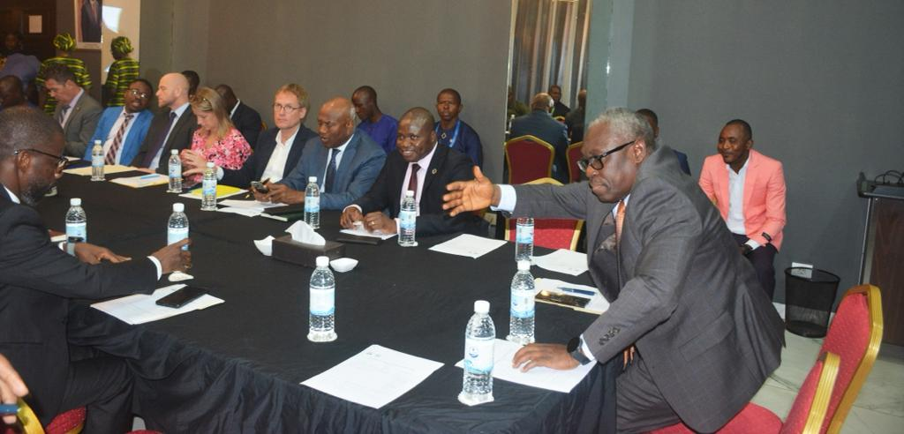
Fig. 3: Minister Sirleaf makes a remark at the opening of the Inter-ministerial Committee on Decentralization meeting at the Royal Hotel.

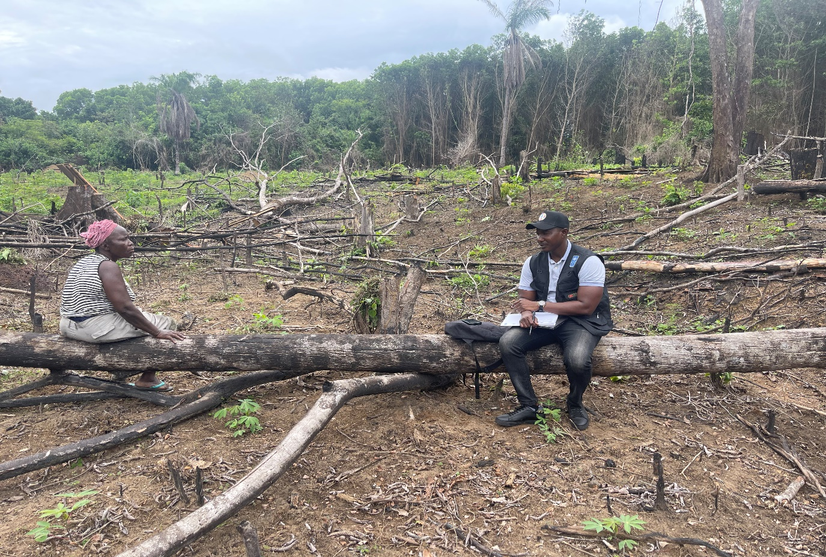Fig. 4: Key Informant Interview being conducted in Gbarma, Gbarpolu County with Ma Dabbah Marshall, Marketing Association Chairlady of Gbarpolu County on awareness/ outreach activities conducted by IREDD.

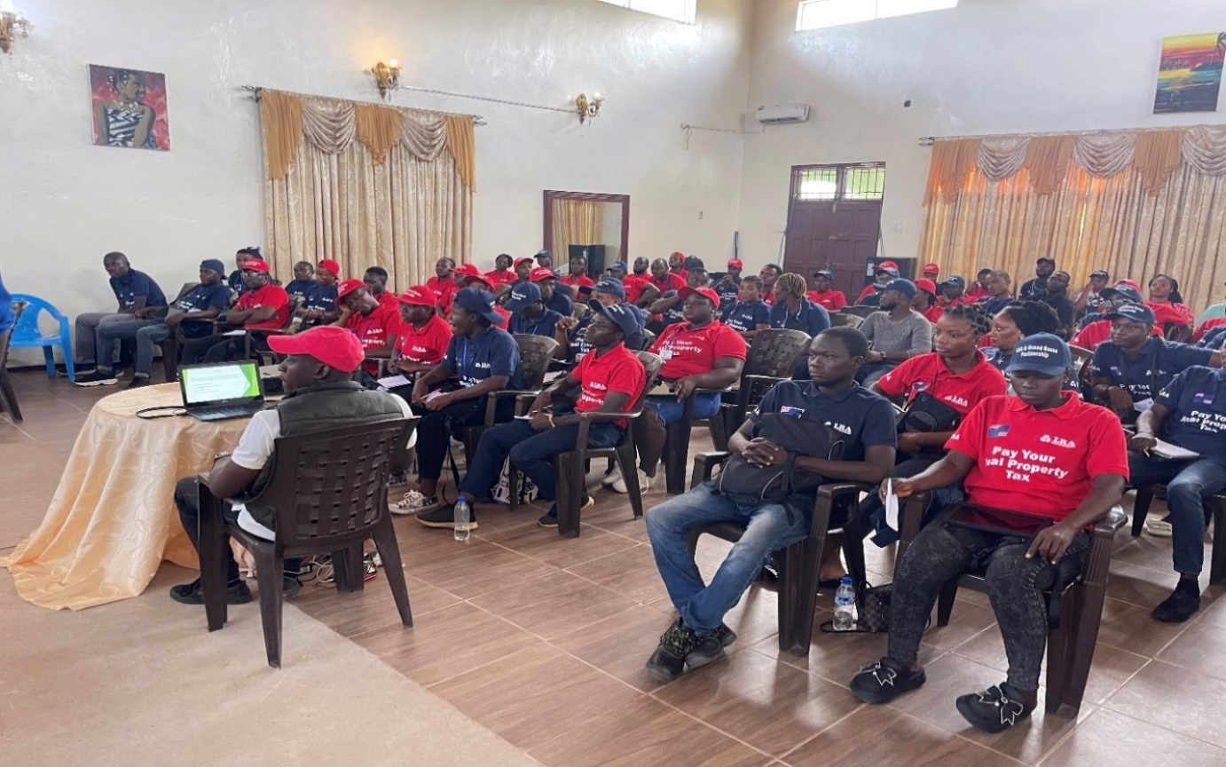
Fig. 5: A cross-section of tax agents recruited for the real property tax expansion project attend Phase 2 of the training exercises at the City Hall in Buchanan City, Grand Bassa County.

